**Leader Overview**

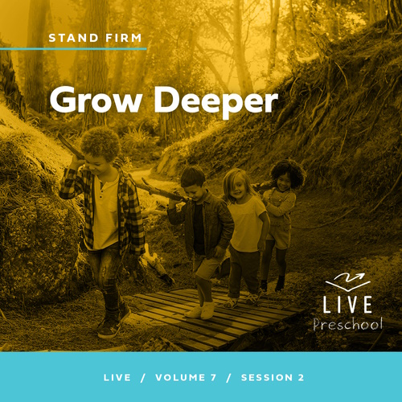

**Volume Overview**

**Stand Firm**

*The world thinks of power as action. Powerful people are able to take control, able to change things. But Jesus blessed the meek, the hungry, and the poor. There is a power this world overlooks. There is power in standing firm in faith. Christians have long stood their ground, not to gain this world’s power but as witnesses to a better world to come. So we stand strong, committed, and bear witness to the world.*

**Session Overview**

**Grow Deeper**

*In this* **Live** *session, preschoolers will discover how to keep growing closer to God. They will explore the story Jesus told about seeds that fell on different types of ground. Through this parable, kids will experience how to keep their hearts soft and ready to hear from God and find out how they can continue to grow closer to Him their entire life.*

**Bible Lesson**

The Parable of the Sower

[Mark 4:1–20](https://ref.ly/logosref/Bible.Mk4.1-20)

**Faith Fact**

I will keep growing closer to God.

**Faith Verse**

[Ephesians 6:13](https://ref.ly/logosref/Bible.Eph6.13) (NLT)

Put on every piece of God’s armor so you will be able to resist the enemy in the time of evil. Then after the battle you will still be standing firm.

**Preparing for the Session**

**Leader Preparation Time: 20–25 Minutes**

|  |
| --- |
| ***You Will Need***  ***Preservice Activities***  *• Toys*  *• Baby doll*  *• Toy car*  *• Hammer*  *• Carrot sticks*  *• Grape halves*  *• Celery sticks*  *• Napkins or small plates, one per kid*  ***Large Group***  *• Bible*  *• Worship songs (Song suggestions: “Movin’ Me” Lyric Video by Amber Sky Records; “Living Color” Lyric Video by Elevation Church Kids; “See a Victory” Lyric Video by Elevation Church Kids)*  *• For groups not using a phone or tablet only, add:*  *• Projector or TV*  *• Laptop*  *•* ***Faith Fact Sound*** *video (bell ringing)*  *•* ***Faith Fact Slide***  *•* ***Faith Verse Slide***  *•* ***Faith Verse Video***  *•* ***Bible Lesson Video A***  *•* ***Bible Lesson Video B***  ***Small Group***  *•* ***Small Group Activity Page****, one per kid*  *• Pencils or pens, one per kid*  *• Crayons or markers*  *• Optional: Small seeds*  *• Optional: Glue or tape*  *•* ***Small Group Feet-to-Floor Game Time****, two per group*  *• Scissors*  *• Envelopes, two per group*  *• Small paper cups, twenty per group*  *• Cookie sheet*  *• Marker*  *To access session content and videos from a computer, visit:* [***BibleEngagementProject.com/downloads***](https://bibleengagementproject.com/downloads) |
| ***Getting Ready***  ***Preservice Activities***  *• Set out toys and snacks.*  ***Large Group***  *• Download videos and slides if needed.*  *• Select worship song(s) and have them ready to play.*  ***Small Group***  *• Print copies of the* ***Small Group Activity Page****, one per kid*  *• Print the* ***Small Group Feet-to-Floor Game Time****, two per group. Then cut apart.*  *• Place a set in each envelope.*  *• Use the marker to label five cups with prayer, Bible, worship, fellowship, and serving.*  ***First time leading* Live *for Preschool? Check out the*** [**Facilitator Guide**](https://0b769b0ed3569ef9d18b-f88d8272f61086866d50d048b43ef630.ssl.cf2.rackcdn.com/sites/biblengagementproject/Listen_Facilitator_Guide.pdf)**.** |

**Preservice Activities**

*See what’s needed at the beginning of the session.*

**Bible Story Warm-Up**

I’d like to find out how old each of you is. *(Allow responses.)* Some of you are exactly the same age, and some of you are different ages. Am I the same age as any of you? *(Group response)* No, I’m a lot older than all of you are.

• *Hold up the baby doll*.

How about a baby? Would a baby be older or younger than you? *(Group response)* What are some things a baby can do? (*Allow responses.)* Those are great answers.

• *Hold up the hammer and then the toy car.*

Can a baby use a hammer? *(Group response)* No. How about drive a car? *(Group response)* No, of course not.

What are some other things babies can’t do?

What are some things babies can’t do, but you can?

What are some things you have to wait until you grow up to do?

Jesus taught us in the Bible that there are a lot of ways we can grow. Today, we’ll learn about this. Jesus wants us to grow to be more like Him. Just like you’ve been growing since you were a baby, we can keep growing closer to God as long as we keep following Him.

**Snack**

**Veggie Flowers (Carrot Sticks, Grapes, and Celery Sticks)**

The Bible story we’ll hear later today is about seeds and plants. Have you ever planted seeds before? *(Group response)* What do seeds become? *(Allow responses.)* Seeds can grow into plants, flowers, fruits, vegetables, and even really tall trees. We eat many things that come from seeds. For our snack today, let’s make a flower from things that grow from seeds. You can use the celery stick or carrot stick for the stem of the flower. Then use the purple grape for the center of the flower.

• *Allow time for kids to complete the snack activity.*

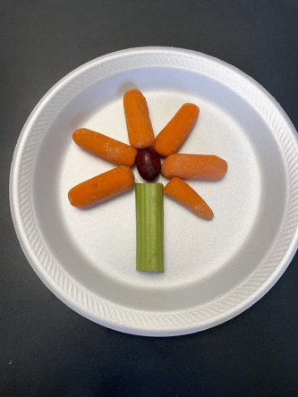

Sometimes things grow by getting bigger, and sometimes things grow by going deeper. Our snack came from seeds planted down in the dirt. Today, we’ll learn about the ways that we can grow closer to God from a story Jesus told about seeds.

**Free Play**

*Any extra time can be spent playing with toys.*

**Transition**

*A few minutes before service begins, have kids make their way to the large group area and sit in their designated areas.*

**Large Group**

**25 Minutes**

*See what’s needed at the beginning of the session.*

**Introduction**

Hi, friends! It’s so exciting to see you all here today. My name is _________. If you’re ready for a fantastic time learning about the Bible *(hold up the Bible),* point to yourself and say, “I’m ready!” *(Group response)*

Today, we’ll learn about a story Jesus told. Wave your hand at me if you love hearing stories. *(Group response)* Great! When Jesus walked the earth, He was an amazing storyteller. Crowds of people would gather to hear Jesus talk about God and tell stories. Today, we’ll hear one of the stories Jesus told about a farmer who planted some seeds.

**Faith Fact**

This Bible story will help us learn how we can grow closer to God all the days of our life. To help us remember that, our Faith Fact is **I will keep growing closer to God.**

• *Show the* ***Faith Fact Slide.***

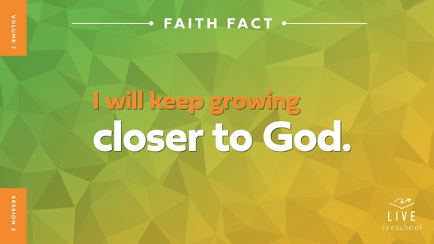

Let’s say it together like we’re seeds that grow. First, crouch down low and touch the floor like we’re tiny seeds in the ground. Whisper the Faith Fact. **I will keep growing closer to God.** Now, let’s stand and stretch out our arms like we’ve grown into big plants and say it again. **I will keep growing closer to God.** Awesome!

**Bible Time**

Our story today shows how important it is to learn from God and His Word, the Bible. Who knows the name of our friend who loves exploring Bible stories with us? *(Allow responses.)* Yes! Let’s see what Lizzy is doing.

• *Play* ***Bible Lesson Video A****.*

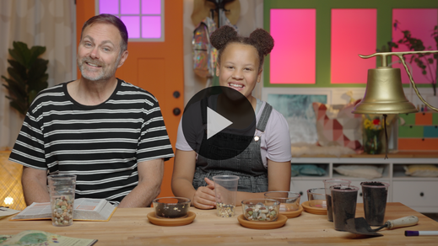

The story Jesus told about seeds was so cool! Wave your hand at me if you love to plant seeds or flowers in the dirt. *(Group response)* Grandpa asked us an important question to think about. He wanted us to think about what we want in our life. Let’s worship God now, and then we’ll come back to that question.

**Worship**

We please God when we learn from His Word, and we also please God when we worship Him. Worshipping God lets us focus on how much He loves us and how much we love Him.

**Praise**

Who wants to thank Jesus for coming to the earth to tell us stories of how to grow close to God? Stretch your fingertips as high as you can. *(Group response)*

Who wants to thank God for the plants He made for us to enjoy? Pat the ground like you’re planting seeds in good dirt. *(Group response)*

Do you want to grow closer to God? Jump as high as you can. *(Group response)*

**Sing**

Let’s use our voices in singing praise to God.

• *Lead the kids in singing one or two songs. See song suggestions at the beginning of the session.*

**Prayer**

That was beautiful to my ears and to God’s heart. Let’s bow our heads and pray.

|  |
| --- |
| *Dear God, thank You for teaching us how to be close to You. We know You want to be close to us because You want to help us. We know You love us so deeply. I pray that You keep these kids close to Your heart all the days of their lives. Amen.* |

**Bible Time cont’d**

• *Start* ***Bible Lesson Video B*** *and pause on the image of the two choices.*

It’s time for Lizzy and Grandpa to come back. Have you decided what you want to see in your own life? Do you want God’s Word to grow good things in your heart? *(Point to “Bible” graphic.)* Do you want to ignore the Bible until you don’t ever think about what God says at all? *(Point to “Bible with X” graphic.)* If you want God to help you grow, wave your hands in the air. If you don’t, bend down low and touch your toes like a seed that didn’t grow.

• *Allow kids to respond.*

Let’s check back in with Lizzy and Grandpa.

• *Play* ***Bible Lesson Video B.***

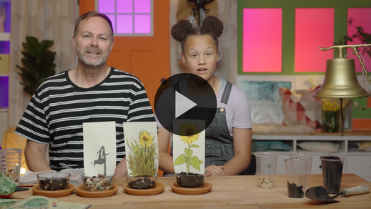

Isn’t it amazing that God will continue to draw us closer to Him our whole life? *(Group response)* Who remembers what happened to the first seeds? *(Allow responses.)* They got scattered on a path where people walk, didn’t they? Let’s march like we’re walking on a path. *(Group response)* Now, let’s be like the bird swooping down to eat the seeds.

• *Demonstrate flapping wings and then opening mouth to eat seeds.*

Hmm. Does anyone remember what happened to the next group of seeds? *(Allow responses.)* They fell among the rocks, and the sun dried them up. Can you bend over at the waist like you got too hot and dried up?

• *Demonstrate bending over at the waist and hanging your head and hands down.*

How about the next group of seeds? *(Allow responses.)* They got choked out by weeds so that they couldn’t grow. Let’s pretend to stop growing.

• *Demonstrate holding your arms tightly against your body.*

**Response Time**

*Play a worship song quietly.*

What happened to the last group of seeds? *(Group response)* Let’s be the plants that grow strong and healthy. Pretend to dig your feet deep into the ground and then stretch out your arms and hands like beautiful branches.

• *Demonstrate extending and waving arms like branches.*

Now let’s put our branches together *(fold hands)* and pray to God who created us to grow closer to Him.

• *Have the kids repeat phrases of the prayer after you.*

|  |
| --- |
| *Dear God, I want to grow closer to You. Help me plant Your Word deep inside where it can grow healthy and strong. I want to listen to and obey You. Amen.* |

**Faith Verse**

One way we grow closer to God is to learn Bible verses from His Word. Let’s say our Faith Verse and do the actions together.

[Ephesians 6:13](https://ref.ly/logosref/Bible.Eph6.13) (NLT)

Put on every piece of God’s armor so you will be able to resist the enemy in the time of evil. Then after the battle you will still be standing firm.

• *Show the* ***Faith Verse Video****.*

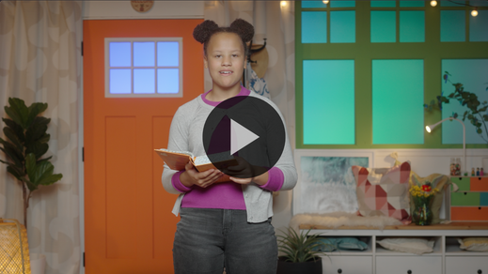

Since this is such a long verse, we’ll work on just the first part of the verse today. Next time, we’ll learn the rest of the verse.

**Ephesians** *(hands at waist, spread apart, palms up and out)*

**6:** *(hands together like a clap)*

**13** *(hands opened to “book”)*

**Put on every piece** *(bring one arm crosswise to pat opposite arm and repeat with other arm)*

**of God’s armor** *(pretend to put on helmet)*

**so you will be able to resist** *(cross forearms together in front)*

**the enemy in the time of evil.** *(put arms out like showing strong biceps)*

Excellent! You’re doing such a great job with this verse!

**Closing**

Did you learn more about God today? *(Group response)* Me, too! I love exploring God’s Word with you and learning Bible verses together. There’s one more thing I love doing with you.

• *Play the* ***Faith Fact Sound*** *video (bell ringing).*

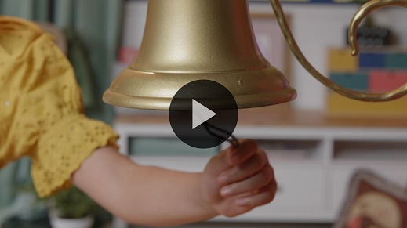

Yay! That sound means we have time to say our Faith Fact one more time. **I will keep growing closer to God**.

• *Show the* ***Faith Fact Slide.***



Let’s picture the biggest plant with the most beautiful flowers as we say it again. Give me a big smile and a thumbs up when you have it in your mind. *(Group response)* Now, let’s say our Faith Fact. **I will keep growing closer to God**. Say it one more time. **I will keep growing closer to God**.

**Dismissal to Small Groups**

Friends, I see you growing to be so beautiful as you plant God’s Word in your life. I’m praying that God will continue to help you grow closer to Him through some really fun activities with your small groups right now.

• *Dismiss the kids by groups.*

|  |
| --- |
| ***Leader Tip:*** *This can be done by assigning color teams or by age groups. Note that some young preschoolers may not know their age. Using a colored sticker, jersey, or wristband will help separate the kids and help identify their small groups.* |

**Small Group**

**25 Minutes**

*See supplies and prep instructions at beginning of session or in each activity below.*

|  |
| --- |
| ***Leader Tip:*** *Small groups can alternate to each circle, or all groups can do each activity at the same time. If you choose to alternate, you will need at least one leader per circle.* |

**Circle 1**

**Group Connection**

**Faith Fact Grow Up**

|  |
| --- |
| *No prep needed for this activity.* |

Who can tell me what our Faith Fact is today? *(Allow responses.)* Great job! Everyone, reach up high and grab your big, booming voice. Let’s say it together as loud as we can. Ready? 1, 2, 3. **I will keep growing closer to God.** For our activity, let’s sit in a circle on the floor.

• *Have kids sit together.*

Let’s go around the circle and say our Faith Fact. Each of you will say one word. When we complete the phrase, we’ll each grow or stand up a little bit. As we keep saying the Faith Fact, we’ll grow taller and taller. Then, when we’re finally all standing up, we’ll say our Faith Fact together and jump as high as we can.

• *Join the kids as you say the Faith Fact together.*

• *Repeat the activity if you have time.*

You all did a great job growing! Sometimes growing in God will happen fast like learning together right now, and other times it will take more time. The good thing is that every day we can make a choice to grow closer to God. The best part of all is that God loves growing closer to us, too.

**Circle 2**

**Activity Page Time**

**Grow Time**

|  |
| --- |
| ***You Will Need***  *•* ***Small Group Activity Page****, one per kid*  *• Pencils or pens, one per kid*  *• Crayons or markers*  *• Optional: Small seeds*  *• Optional: Glue or tape*  ***Getting Ready***  *• Print copies of the* ***Small Group Activity Page****, one per kid.* |

There are some things that we have to do to grow in life. We have to eat fruits and vegetables and drink water. When we exercise, it makes our muscles grow. When we sleep, it helps our body grow. There are things that we can do to grow closer to God, too. Does anyone here want to grow closer to God? *(Group response)*

Awesome! What are some ways we can grow closer to Him? *(Allow responses.)* Those are great answers. Our Faith Fact today is a great reminder to do this. Let’s say it all together. Ready? **I will keep growing closer to God.**

• *Hand out a copy of the* ***Small Group Activity Page****, a pencil, and crayons to each kid.*

On our page are pictures from our Bible story. I’ll read what Jesus told us about the seeds in the story. As I read, see if you can figure out which picture Jesus talked about first, second, third, and fourth. Ready? *(Group response)*

• *Read* [*Mark 4:3–8*](https://ref.ly/logosref/Bible.Mk4.3-8)*. Pause after each description and help kids select the correct picture.*

Good job! One of these pictures shows what we should be like if we want to grow closer to God. Can you point to that picture? *(Group response)* Now, circle that picture.

• *Let kids circle the flowers that are growing strong.*

Excellent! You listened very carefully to the story Jesus wanted us to hear. Go ahead and color the pictures.

• *Optional: Allow kids to glue or tape seeds to their* ***Small Group Activity Page*** *for a tactile experience.*

• *During the activity, interrupt and practice the Faith Fact:* **I will keep growing closer to God.**

• *Play the* ***Faith Fact Sound*** *video. Review the Faith Fact even if you can’t play the sound.*



**Circle 3**

**Feet-to-Floor Game Time**

**Armored Race Relay**

|  |
| --- |
| ***You Will Need***  *•* ***Small Group Feet-to-Floor Game Time****, two per group*  *• Scissors*  *• Envelopes, two per group*  ***Getting Ready***  *• Print the* ***Small Group Feet-to-Floor Game Time****, two per group. Then cut apart.*  *• Place a set in each envelope.* |

This game will be a race. I’ll divide the group into two teams. You’ll race to build a soldier wearing armor like our Faith Verse talks about. Armor is used to protect soldiers when they are in a fight. God has given us armor to protect us against any attack of the enemy. When we remember to wear the armor that God has given us, there’s nothing the enemy can do to keep us from doing everything God wants us to. Before we race, let’s say our Faith Verse together.

• *Lead the kids in saying the Faith Verse while doing the actions.*

**Ephesians** *(hands at waist, spread apart, palms up and out)*

**6:** *(hands together like a clap)*

**13** *(hands opened to “book”)*

**Put on every piece** *(bring one arm crosswise to pat opposite arm and repeat with other arm)*

**of God’s armor** *(pretend to put on helmet)*

**so you will be able to resist** *(cross forearms together in front)*

**the enemy in the time of evil.** *(put arms out like showing strong biceps)*

Great job! Now, let’s get into teams and play the game. When it’s your turn, you’ll run down and choose one piece of the armor picture. Then, you’ll come back and see if you can tell where it goes in the picture. The first team to finish the armor picture wins.

• *Divide the group into two teams.*

• *Spread out the pieces at the end of the relay area.*

• *When kids complete the pictures, lead them in saying the Faith Verse again.*

• *If time allows, play again. Consider using different actions for kids to race from one side of the room to the other: hop, skip, crawl, etc.*

**Circle 4**

**Hands-On Learning**

**Growing Strong Object Lesson**

|  |
| --- |
| ***You Will Need***  *• Small paper cups, twenty per group*  *• Cookie sheet*  *• Marker*  ***Getting Ready***  *• Use the marker to label five cups with prayer, Bible, worship, fellowship, and serving.* |

Today, we’ve learned about how we can grow closer to God. There are so many ways that we can learn about who God is and how to be like Him. One of the ways we do that is by reading God’s Word.

• *Hold up the cup that says “Bible.”*

Does anyone know what we call God’s Word? *(Allow responses.)* That’s right. It’s the Bible.

• *Hold up the remaining labeled cups as you talk about them.*

We can also grow close to God by worshipping Him, serving others, and praying, which is talking with God. We can spend time with other people who love God, which is called fellowship. These are the things that help us get closer to God.

• *Place the five cups upside down on the floor so they are not evenly spaced.*

Is doing each of these things one time enough? *(Group response)* Hmm, I don’t think so. Let me see if this is strong.

• *Place a cookie sheet on top of the cups.*

• *Then stand on it with one foot and press down hard enough to crush one or more of the cups.*

That didn’t quite work. I think we need to add some more cups. That doesn’t mean that we need to add more things to do to grow closer to God. It just means we need to spend more time doing them. The more time we spend with God—worshipping Him, praying, reading the Bible, serving others, and being with people who love Him—the closer we will grow to Him. Let’s add lots of cups to represent that.

• *Using the other cups, allow the kids to help you place the cups together. They do not need to touch, but they need to be spaced closely and evenly under the cookie sheet.*

Okay, let’s see if it’s strong now.

• *Choose a kid as a volunteer. Lift them up to stand centered on top of the cookie sheet*

Wow! The cups are holding up! It’s amazing what can happen when we grow closer to God!

**Dismissal**

• *Play the* ***Faith Fact Sound*** *video (bell ringing).*



• *Show the* ***Faith Fact Slide.***



Today has been amazing! In fact, throughout our time together we have been living out our Faith Fact. We have been growing closer to God. Let’s do one more thing together. Let’s say our Faith Fact as loud as we can. **I will keep growing closer to God.** Amazing! I had a blast learning with you today, and I can’t wait to do it again soon!

• *Send home the* ***Small Group Activity Page*** *with each kid.*

• *Remind parents that there are* ***Family Devotions*** *available on the app to do with their kid.*

• *Tell everyone the date and time for the next session.*